# Arduino Components

Arduino is built from the following components:

* **1 button** to start the system
* **Analog temperature sensor** to measure the indoor temperature
* **1 LCD screen** to display indoor and outdoor temperature
* **1 buzzer to emit a sound** if temperature is outside the limits
* **2 RGB Led** to display the status of the indoor and outdoor temperatures
  + **Green** if temperature is within limits
  + **Red** if temperature if higher than max temperature
  + **Blue** if temperature is lower than min temperature

## Simulator

The simulator and source code written in C/C++ can be found here: <https://wokwi.com/projects/360666315403952129>

## Examples:

Indoor and outdoor temperatures are within the limits:

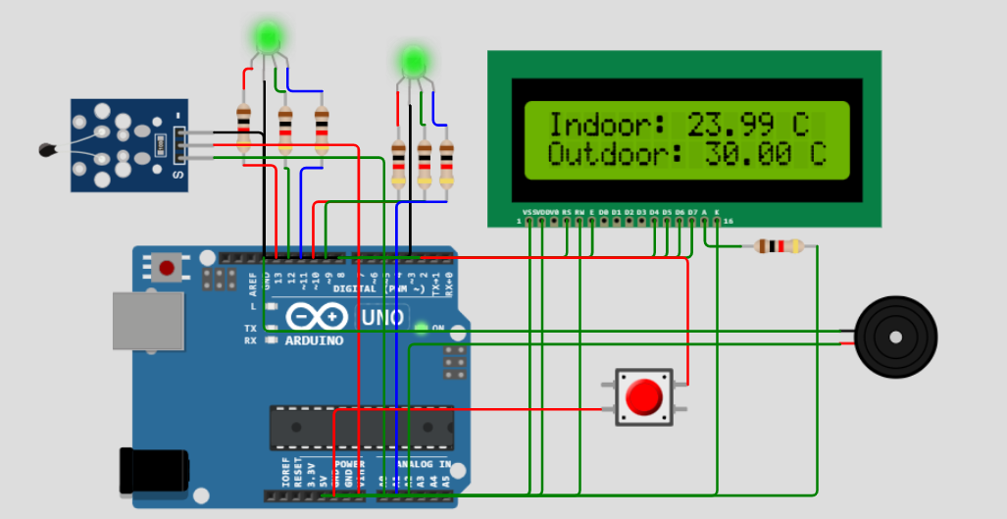

Outdoor temperature is higher than limit: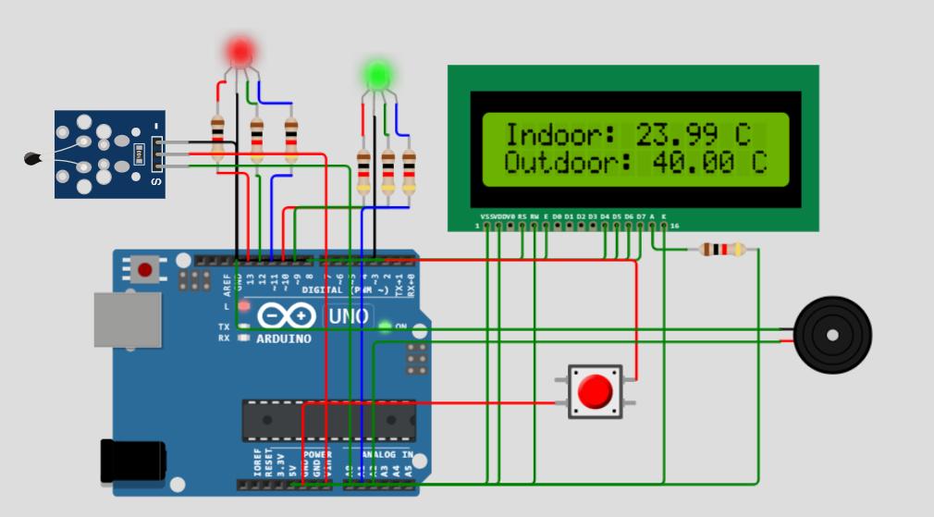

Outdoor temperature is lower than limit:

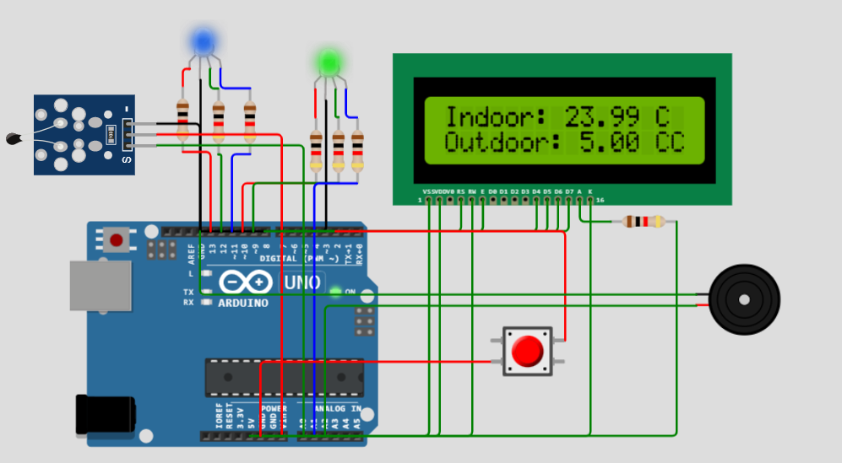

## Class diagrams

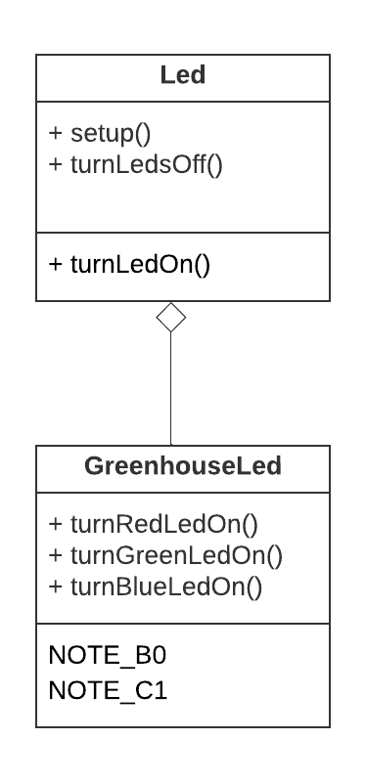

# WPF Application

When Arduino is connected to PC then a screen displays the indoor and outdoor temperatures. The outdoor temperature is red from a third party called **Meteomatics**.

A timer runs every hour to read the outdoor temperature and another timer runs every 5 minutes to read the indoor temperature from the Arduino.

